C:\Users\MyPC\Pictures\RAGE ID\ID RAGE7.tif

C:\Users\MyPC\Pictures\RAGE ID\ID RAGE7.tif

**Danao City, Cebu, Philippines**

**C E R T I F I C A T I O N**

AUGUST 23, 2025

This is to certify that **Vicente J. Batican** is a regular member of **RADIO AMATEUR GROUP FOR EMERGENCY-7DC INC (RAGE -7DC)** base in Danao City, Cebu. He has attended and participated with the group’s seminar conducted by the group.

This certification is being issued for the renewal of his Amateur Radio Station License.

Very Truly Yours,

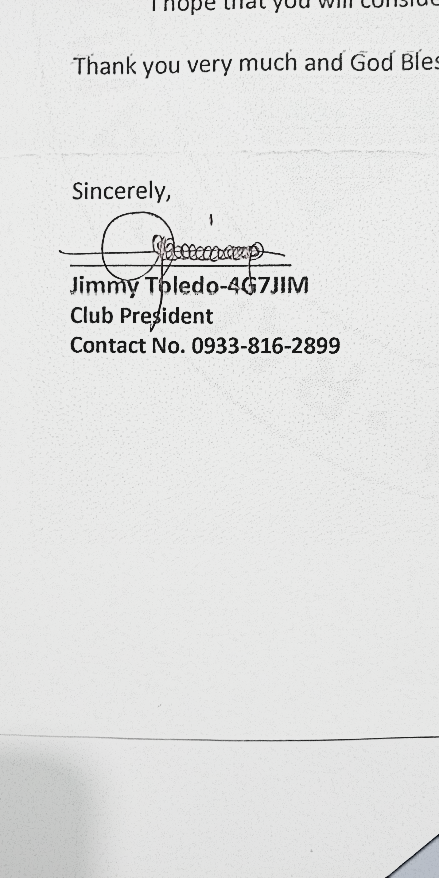

Control No. RAGE 7 DX-DAG-001-2025